
Real-Time Open-Source Transaction Monitoring

AI and Machine Learning in Tazama for Calibration and Anomaly Detection
Product Guidance Document
Authors: Justus Ortlepp - Tazama
September 2025
Table of Contents
1 Introduction 3
1.1 Tazama System Overview 3
1.2 Tazama Ecosystem Overview 4
1.3 Document Purpose 6
1.4 Background Reading 6
2 AI/ML-Based Modeling Overview 8
2.1 Problem Statement 8
2.2 Model Calibration 8
2.3 Anomaly Detection 13

Introduction

Tazama System Overview
The Tazama Transaction Monitoring System is a rules-based forward-chaining inference engine that ingests transaction data as JSON-formatted ISO20022 messages and evaluates the data in real-time. Tazama uses a number of pre-built and configured rule processors to look for fraud and money-laundering behaviors. Rule results are summarized into fraud and money-laundering scenarios (known as typologies) and the system is able to block or flag transactions if typologies breach configured thresholds.
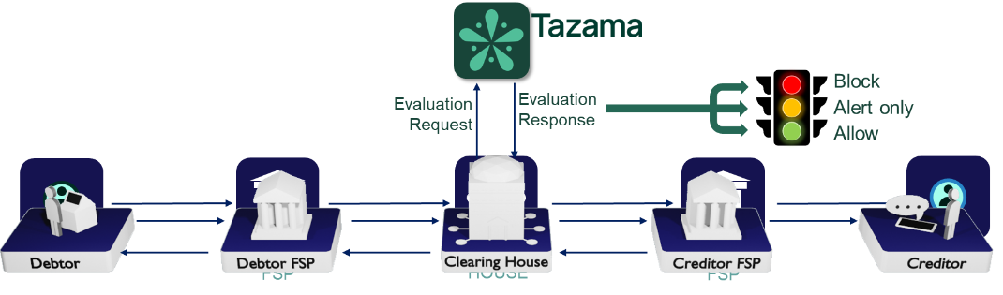
The core detection capability within the platform is distributed across 3 distinct steps in the end-to-end evaluation flow.
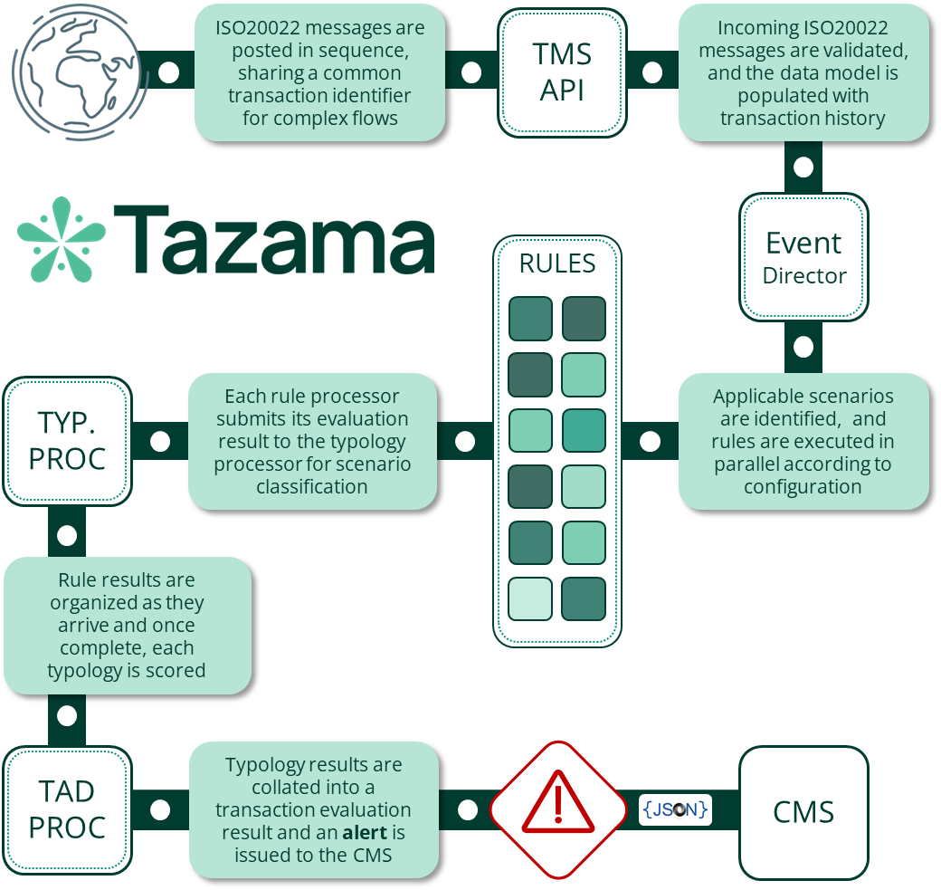
Once data is ingested into the transaction history by the TMS API, the Event Director (ED) performs an initial "triage" step to determine if the transaction should be inspected by the platform, and in what way. Currently this is a very simple decision based on the transaction type only (i.e. pain.001, pain.013, pacs.008 and pacs.002), though we envisage that the decision-making here can be more complex in the future by inspecting attributes contained in the message. For now, the ED uses the transaction type to select the typologies that are to be evaluated and triggers the rules required by the typologies. The ED routing is configured via a network map that defines the hierarchy of typologies and rules.
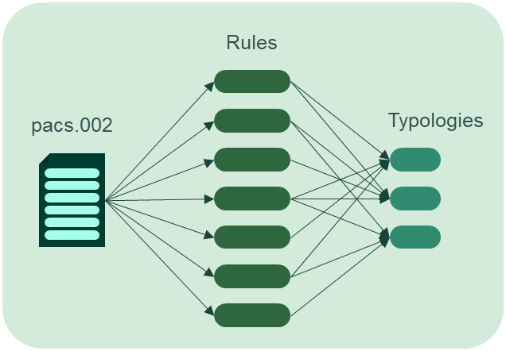
Each rule processor that receives the trigger payload from the Event Director evaluates the transaction and the historical behavior of the transaction participants according to the rule’s specification and configuration. Rule processors are driven by a combination of parameters and result category specifications to determine only one of a configurable set of related outcomes. The rule outcome is then submitted to the typology processor for scoring.
The typology processor assigns a weighting to each rule outcome as it is received based on the rule’s parent typologies’ configurations. Once all the rule results for a specific typology have been received, the typology adds all the weighted scores together to form the typology score. The typology score can be evaluated against an "interdiction" threshold to determine if the client system should be instructed to block a transaction "in flight". The typology configuration also contains an investigation threshold that will trigger a review or investigation process at the end of the transaction evaluation.
Once these three steps are complete, the evaluation of the transaction is wrapped up in the Transaction Aggregation and Decisioning Processor where the results from typologies are combined and reviewed to determine if an investigation alert should be sent to the Case Management System. If any typology had breached either its investigation or interdiction threshold, the system would trigger an investigation alert for that transaction.
The Tazama system is currently provided as a software engine and as such is generally implemented as a back-end service that taps into transaction flows.

Tazama Ecosystem Overview
The Tazama Transaction Monitoring Service is intended as a core component of a wider ecosystem that comprises of several components designed to combine into a comprehensive fraud and money-laundering management ecosystem.
These features can be summarized as follows:

Data Integration Software Development Kit
This component is designed to accelerate the deployment of Tazama into a new environment by allowing an implementer to rapidly create and implement REST API-based interfaces and end-to-end data pipelines in the Tazama Transaction Monitoring Service.

Relay Service Enhancement
The Relay Service component in the Tazama ecosystem is a light-weight point-to-point router for message traffic generated by Tazama into downstream systems, such as the Case Management System and upstream systems, such as the client transaction system. The Relay Service is designed to be highly modular and extensible and allows for multiple output interfaces that can be selected at deployment, with an easy-to-use integration pattern for adding additional target interfaces.

Case & Investigation Management System
Every alert that is generated out of the Tazama Transaction Monitoring Service (TMS) must be investigated to either confirm or refute the suspicious behavior identified by the TMS. This is firstly required to maintain the good health of the monitoring service itself, but if suspicious behavior is confirmed, the operator of the TMS also has an obligation to investigate the alert for fraud and money-laundering regulatory and legislative enforcement purposes.
The Case and Investigation Management System provides the processes and the tools to assist investigators in the fulfilment of this obligation.
The Case and Investigation Management System also contains an AI-powered Alert Triage Module that tries to automatically validate, classify and prioritize the alerts generated out of the TMS before an investigator is assigned to minimize unnecessary investigative effort.

Data Lakehouse
The Tazama Data Lakehouse ingests evaluation results data and transaction history as an output of the TMS, and also provides a centralized analytics storage solution for further data enrichment and analysis in support of case management and model development and refinement. Tazama has implemented a data lakehouse, as opposed to a more traditional data warehouse or data lake, to provide the most appropriate foundation in support of AI and Machine Learning processing.

Business Intelligence, Analytics and Reporting
To unlock the most value out of the data that Tazama accumulates as part of its core transaction monitoring function, the Tazama ecosystem contains a fully integrated and flexible Business Intelligence and Analytics platform built around JupyterLab, one of the foremost tools for data science, Artificial Intelligence, and Machine Learning available as an Open-Source Software product today.
The Tazama Business Intelligence, Analytics and Reporting component provides the reporting and advanced modeling capabilities for model management and model development, as well as standard reporting for overall operational management of the ecosystem and regulatory reporting to fulfil regulatory obligations.

Model Management
The Tazama Model Management component, containing a configuration utility and a low-code rule-builder, provides accessible tools to an operator to add new rules and typologies and fine-tune their existing rules and typologies.

Simulation Sandbox
The Business Intelligence, Analytics and Reporting module, and the Model Management module, are supported by a simulation sandbox where new models can be tested before they are deployed into a production system.

Document Purpose
The purpose of this document is to provide an overview of the vision for AI/ML-based model calibration and anomaly detection to aid in the design and development of this component in the Tazama ecosystem.

Background Reading
For background, I suggest reading:
https://github.com/tazama-lf/docs/blob/dev/Product/Creating-and-Maintaining-Processors/Introduction.md
https://github.com/tazama-lf/docs/blob/dev/Product/Creating-and-Maintaining-Processors/Tazama-Rules-Life-Cycle.md
https://github.com/tazama-lf/docs/blob/dev/Product/configuration-management.md
https://github.com/tazama-lf/docs/blob/dev/Product/processor-results-propagation.md
https://github.com/tazama-lf/rule-901/issues/137

AI/ML-Based Modeling Overview

Problem Statement
Calibration is intended to improve Tazama detection effectiveness by recommending updates to the rule and typology configurations for rules and typologies currently deployed. The number of variables involved are such that the calibration simply cannot be performed manually and automation is essential.
Similarly, the process of mining transaction data and investigation outcomes for new patterns of behavior and then converting those patterns into new rules and typologies, is an extremely time-consuming and intricate task and well-suited an AI/ML-based approach.
Finally, given Tazama's target user-base, it is somewhat unlikely that all of the end-users in Tazama's constituency will have the skill and expertise required to operate AI/ML-based processes. A lack of budgetary funding will further hamper their ability to outsource these processes to the highly skilled and very expensive resources that are needed.
Assuming the very likely lack of technical capability in a DIY setting, or a small system integrator's limited scale of operations, it is essential for these process to be automated as much as possible, and to be made as easy as possible, for Tazama to be accessible to all users.

Model Calibration
This is one of the most important ongoing maintenance process in Tazama. This activity is effectively then the automation of "hard" data science processes and will likely involve more traditional AI/ML activities and will also (at least initially while we figure out how, and how well, it works) contain a "human in the loop".
For the calibration, we are considering the following broad approach:
- Performance reporting
- Model calibration
- Configuration updates
- Testing
- Deployment

Performance monitoring
Performance monitoring is where the BIAR system will contain reports that track the accuracy of evaluations using the current system configuration. Considering that the currently implemented models offer a "prediction" about whether or not a transaction contains fraud or money-laundering, and then further assuming that this prediction is validated during an investigation process (confirmed or refuted), the data in the data lakehouse will then contain enough information for a confusion matrix to be generated in a Jupyter Notebook. For example, the confusion matrix may look as follows:

 | Predicted: Scam | Predicted: Not Scam | Row Total
Actual: Scam | 80 (TP) | 20 (FN) | 100
Actual: Not Scam | 15 (FP) | 885 (TN) | 900
Column Total | 95 | 905 | 1000

With key metrics presented as follows:
Metric | Formula | Result
Accuracy | (TP + TN) / Total | 965 / 1000 = 96.5%
Precision | TP / (TP + FP) | 80 / 95 = 84.2%
Recall | TP / (TP + FN) | 80 / 100 = 80.0%
F1 Score | 2 × (Precision × Recall) / (P + R) | ≈ 82.0%
False Positive Rate | FP / (FP + TN) | 15 / 900 = 1.67%
False Negative Rate | FN / (TP + FN) | 20 / 100 = 20.0%

The metrics must be periodically tracked and compared and downward trends in the metrics should then trigger a review (recalibration) of the models used to "predict" fraud.
Notes:
- It is extremely unlikely that the system will be able to provide a single confusion matrix to govern detection behavior across the entire system. Fraud typologies are vastly different from AML typologies, even if they use the same rules. And a batch of fraud typologies, for example, are vastly different from each other because they will all use different rules, and attribute different importance to the same rules. We can therefore assume that we will be measuring each typology separately and also calibrating each typology individually. So, for example, given Tazama's current default deployment with 33 typologies, that's 33 different calibration models. Per tenant. For a single transaction type.

Model Calibration
For any given "model", which in Tazama is basically a typology, the model contains a number of variables that can be adjusted to change the model's detection behavior:
- Rule parameters (e.g. date ranges, comparison tolerance threshold, etc)
- The classification of the rule's query result into categories (usually about 3 buckets)
- The specific rules in a typology
- The weightings of each of the rule buckets
- The formula for calculating the typology score
- The threshold for investigation in the typology
- The threshold for blocking a transaction in the typology
For the classification of results into buckets, we are proposing a change to report the query result as part of the rule output so that this value can be available directly for calibration purposes. The current bucketing system creates a "fuzziness" in the rule processor results that was intended to aid manual calibration but may not be necessary in (and may in fact hamper) AI/ML calibration.
The current model looks like this:
With the removal of the buckets, the model will look more like this:
Spoiler: This will effectively allow us to convert the current rule and typology scoring approach to a multi-dimensional linear regression formula:
Suspicious transaction = offset + ruleResult₁ * coefficient₁ + . . . + ruleResult_{n} * coefficient_{n}
If we normalize this result, we should be able to get a percentage that we can evaluate against the thresholds for investigation and/or interdiction.
What we want to be able to do in the calibration is to determine the offset, terms, and coefficients for the linear regression formula, as well as the thresholds at which we will consider the transaction suspicious enough to investigate and/or block.
At the very least, we want to:
- Calculate the best offset
- Calculate the coefficients for each of the rule processor results
- Calculate the thresholds for investigation and interdiction
- Identify rules that can be eliminated
- Possibly identify rules that can be added (from existing rules)
Additionally, and perhaps a little more complicated, we want to calculate the parameters for the rule queries that are used to determine behavior, but this process is likely going to require a different modeling approach.
For example, let's look at something like rule 010 - "Increased account activity: volume - debtor". This rule models the debtor's outgoing volume over the last day against a histogram of previous volumes (configurable bands based on standard deviations) over the life of the platform. The rule processor expects a single parameter, evaluationIntervalTime, that defines the size (in milliseconds) of the intervals according to which the transaction counts will be partitioned:
The expectation is that different intervals may be required for different environments, and that the optimal parameter value will need to be determined for each unique environment.
A change to rule parameters may change the independent variable.
One of the biggest differences in the modeling approach here would be that the model cannot simply rely on the data produced in the alert (independent variables) and the investigation outcomes (confirmed or refuted), but actually needs to be modeled against the source data as well to determine, for that particular rule, what the optimal parameter value would be that would maximize the impact of the independent variable on the prediction.
There is also a good chance here that the same rule processor may require different parameters for different typologies, for example, if we were using rule 010 in a scam typology, we want to calculate the independent variable over monthly intervals, but if we were using rule 010 in a money laundering typology, we may want to calculate the independent variable over daily intervals.
A note on LLMs: It makes sense to support the user performing the calibration process with access to an LLM. Even something as "generic" as ChatGPT contains enough inherent knowledge about linear regression modeling to be able to help the user interpret the results of the modeling process and can guide the user on what else to consider or try to improve the model outcomes. While Tazama does not necessarily need to integrate or implement an LLM directly, we can certainly explore integration and make a recommendation about the feasibility and effort required.

Configuration updates
Once the modeling process has determined what the most appropriate new configuration values are for the rule and typology configurations, a user will create a new draft version of the configuration documents through the Tazama Configuration Service.

Testing
It is generally expected that the model training process will include a testing step to validate the model, but as part of the configuration process, there will be a more focused model testing step based on the updated configurations. This testing is intended to prove more that the user has faithfully implemented the model recommendations (i.e. testing the configuration process outcomes against the model training outcomes) and that the new configuration is shown to have improve the system's current configuration.
This testing will be conducted in the Model Management environment over data in the Simulation Sandbox. The new configuration will be tested over a selection of transactions and the outputs will be validated against the model outputs during training and prior prediction results from the system. We expect that this evaluation will be the comparison of the key metrics used to measure model performance. The results of this evaluation will be submitted along with the updated configurations to a supervisor for review and approval.

Deployment
Once the supervisor has reviewed and approved the updated configuration, the configuration can be deployed to the production environment to replace the current configuration.
And from here the cycle will repeat itself, starting with the ongoing monitoring of the model performance.

Anomaly Detection


This is an area where we have less guidance to offer, except some broad intentions.
The purpose of anomaly detection would be to evaluate:
- historical fraud and money-laundering alerts,
- the investigation outcomes of those alerts,
- likely also the transactional data for the participants in those transactions, and
- possibly also any additional connected related data that we may have access to,
to determine if there are any new rules or typologies evident in this information that we can then build or configure to better detect, or improve our detection of, suspicious transactions.
To a certain extent we would expect that this process would be most useful in improving the detection of previous "False Negatives" where the system failed to detect a behavior that was then reported after the fact. Either a customer complained that they were defrauded, and the initial investigation outcome of the alert (no fraud predicted) is now changed from "confirmed" to "refuted", or perhaps a regulator approached the operator to request an inquiry into money laundering where Tazama had previously determined that no money-laundering was evident.
This modeling process may also lean heavily on an LLM to guide the inexperienced user in interpreting the outcomes of the modeling process and suggest actions, which may end up being more "open world" than "railroad".
The translation from the discovered behavior to an actual rule processor is also less clear here and may require some experimentation on our part. At worst, this process may actually only become apparent when we are able to test this modeling process against real data. In general, the overall process here is expected to follow these steps:
- Performance reporting
- Modeling for rule and typology discovery
- (Optional) Rule development
- (Optional) Typology definition
- Model calibration
- Configuration updates
- Testing
- Deployment

Performance Reporting
To a certain extent, we can use the same reports from the ongoing model performance monitoring here as well, perhaps with specific attention to the key metrics related to the false negatives. If the regular calibration does not improve the key metrics in any significant way, then the anomaly detection modeling may be called for.

Modeling for rule and typology discovery


(Optional) Rule development
If the modeling process indicates that any new rules are required, the user will build these rules in the Tazama Rule Studio.

(Optional) Typology definition
If the modeling process indicates that any new typologies are required, the user will configure these in the Tazama Configuration Service.

Model calibration
With new rules and/or new typology, we should now have a new prediction model that we can deploy, but we should also first check if this model is able to achieve the requirement metrics. In the model calibration documented above, we are attempting to determine the optimal configuration values for our existing models, but in this case, we need to determine the optimal configuration values for a model that does not yet exist in our production environment. What this means is that this model, and in particular the proposed rule processor, does not yet have the independent variables that are to be calculated over the transaction history.
The model calibration process here will need to include the calculation of these independent variables first, so that they can then be used as input into the model training process. Once the independent variables have been calculated, the modeling process is likely to be fairly similar to the calibration process where the typology result can be predicted, and the prediction can be compared to the actual investigation results of those transactions through a confusion matrix.

Configuration, etc.
From here the process is expected to be roughly the same as above. The configuration of our new rules and typologies will be facilitated in the Tazama Configuration service. The configuration will be tested in the Simulation Sandbox and the results will be submitted for approval, and once approved, the new rules and/or typologies will be deployed into production and their performance monitored.

